# FINAL TESTING – Release 2 – 31st May

Story 8: Open PDF File

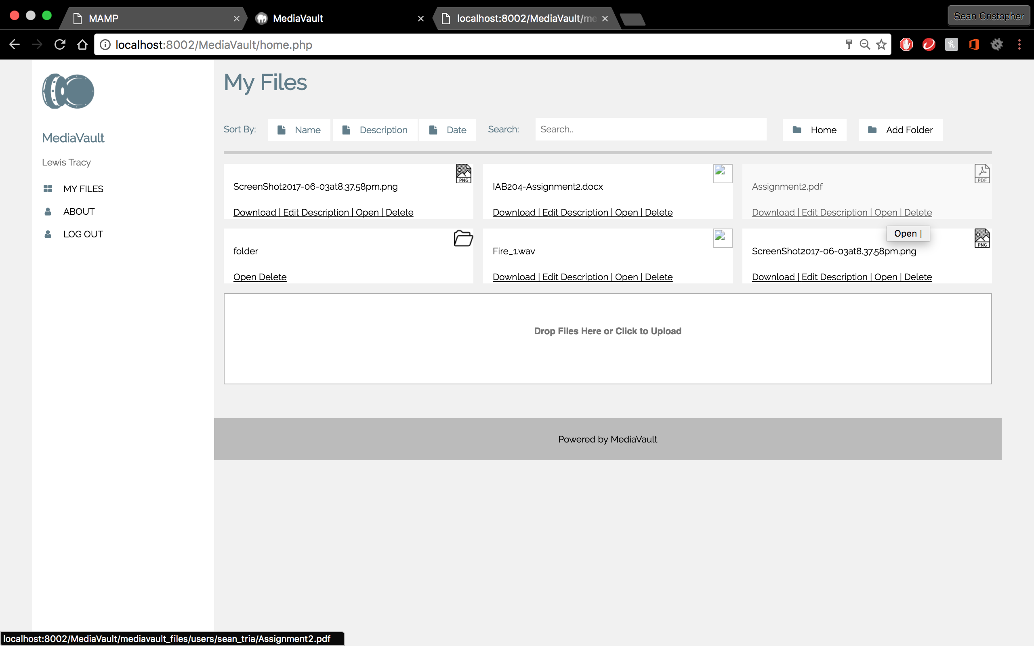 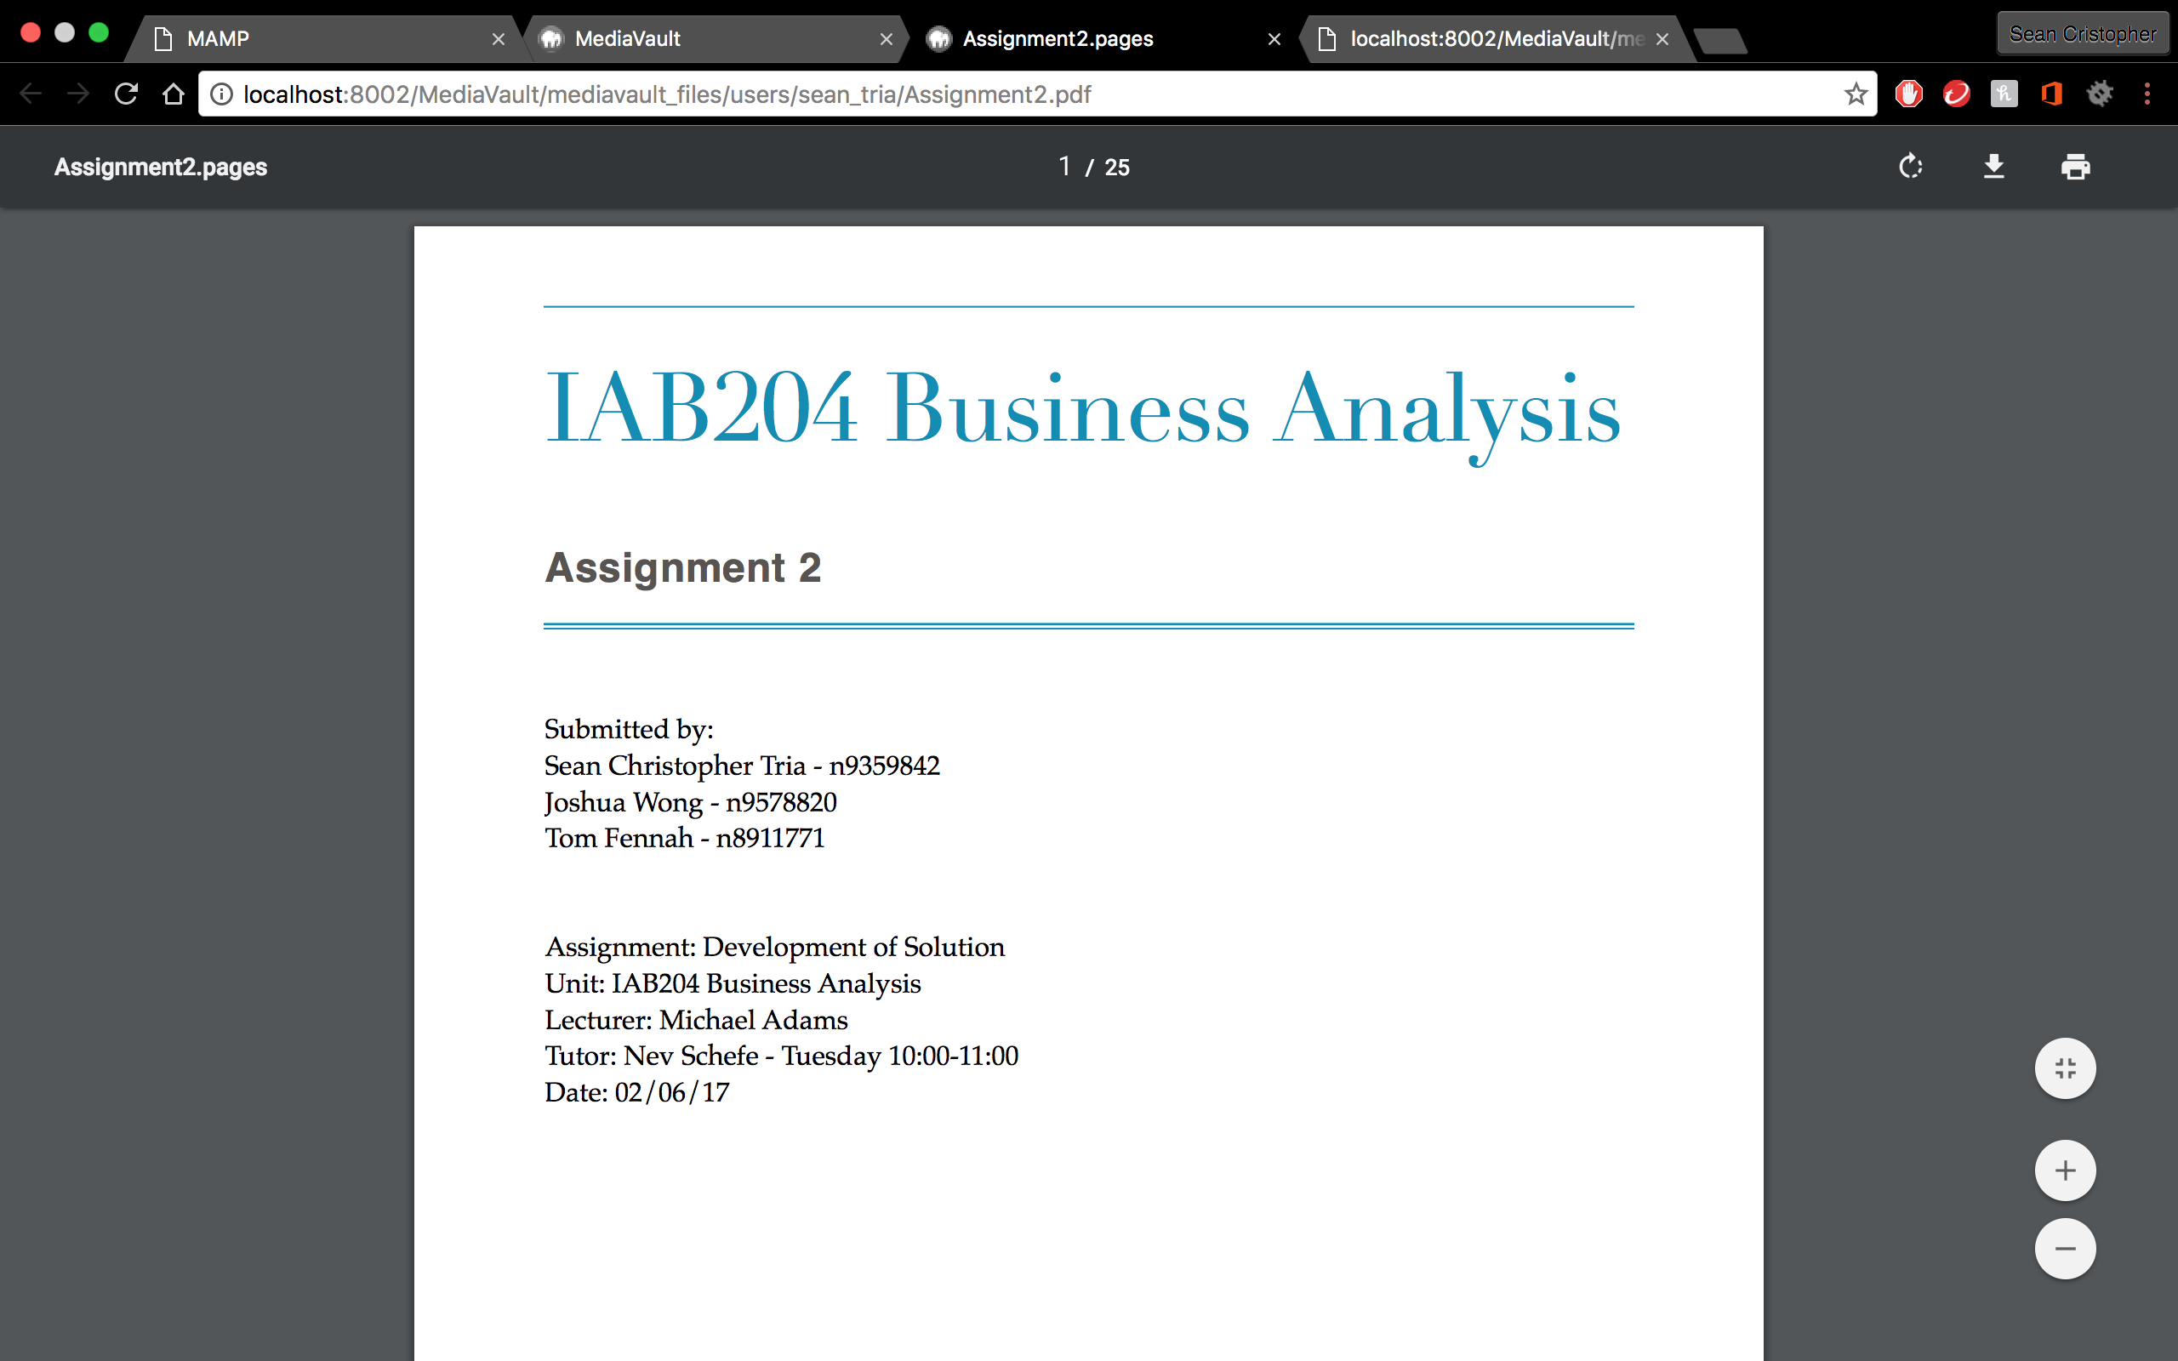

* “Open” button is independent for each file/folder
* PDF files successfully open on browser

Story 8B: Open my eBook File

 

* “Open” button is independent for each file/folder
* PDF files successfully open on browser

Story 9: Open my Audio File

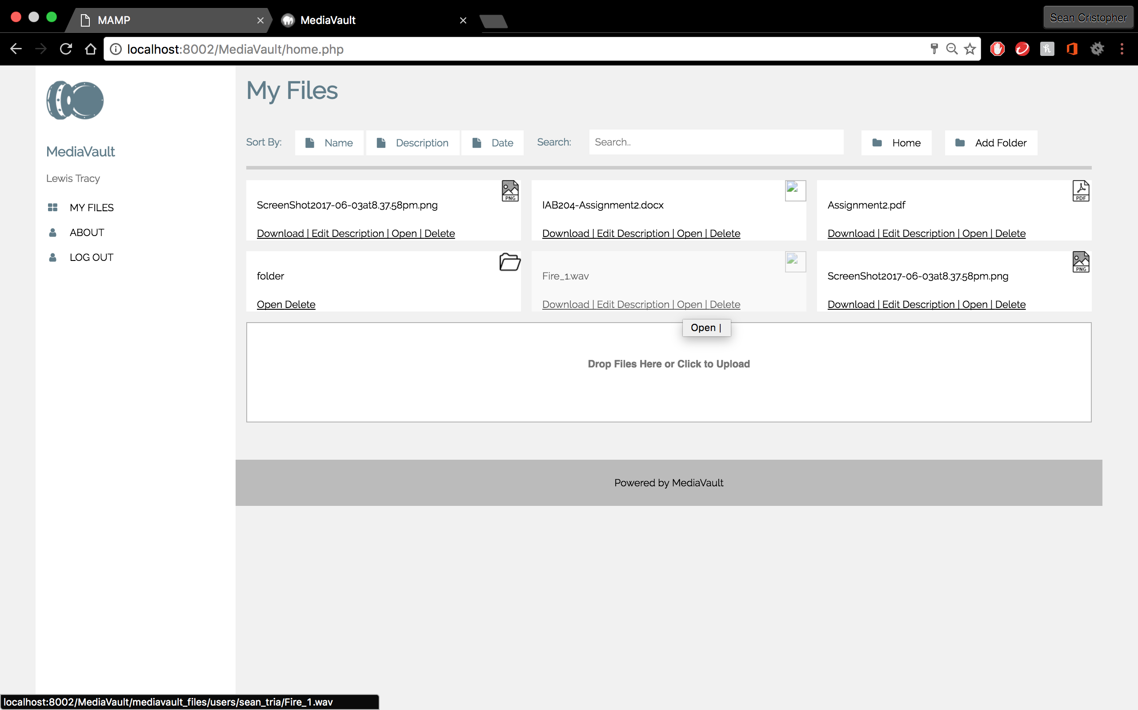 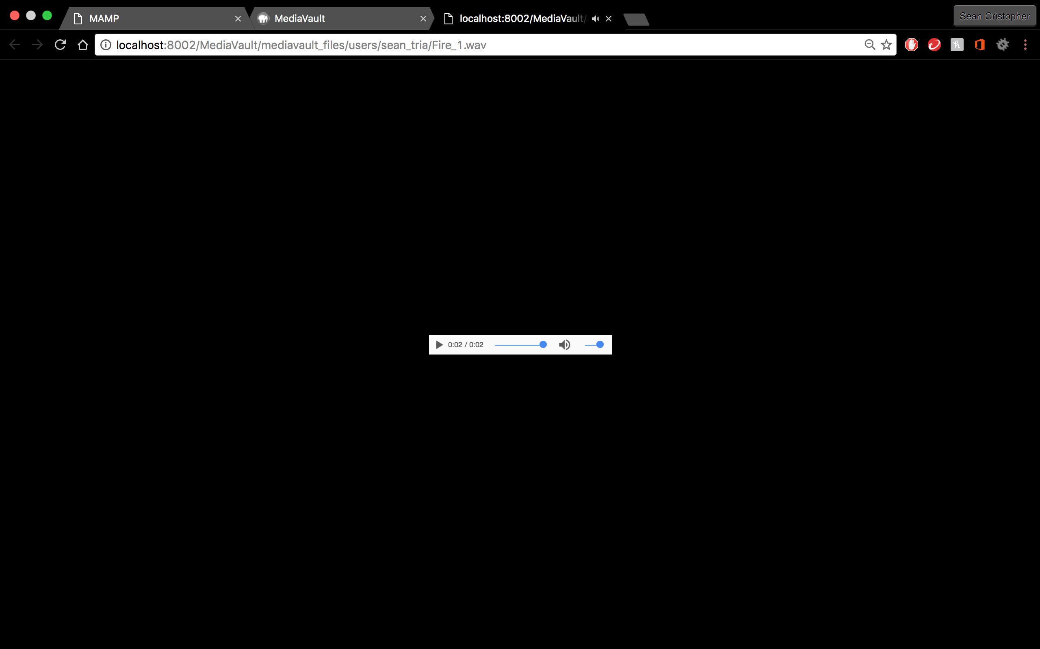

* “Open” button is independent for each file/folder
* Audio files successfully open on browser and plays

Story 10: Open my Picture File

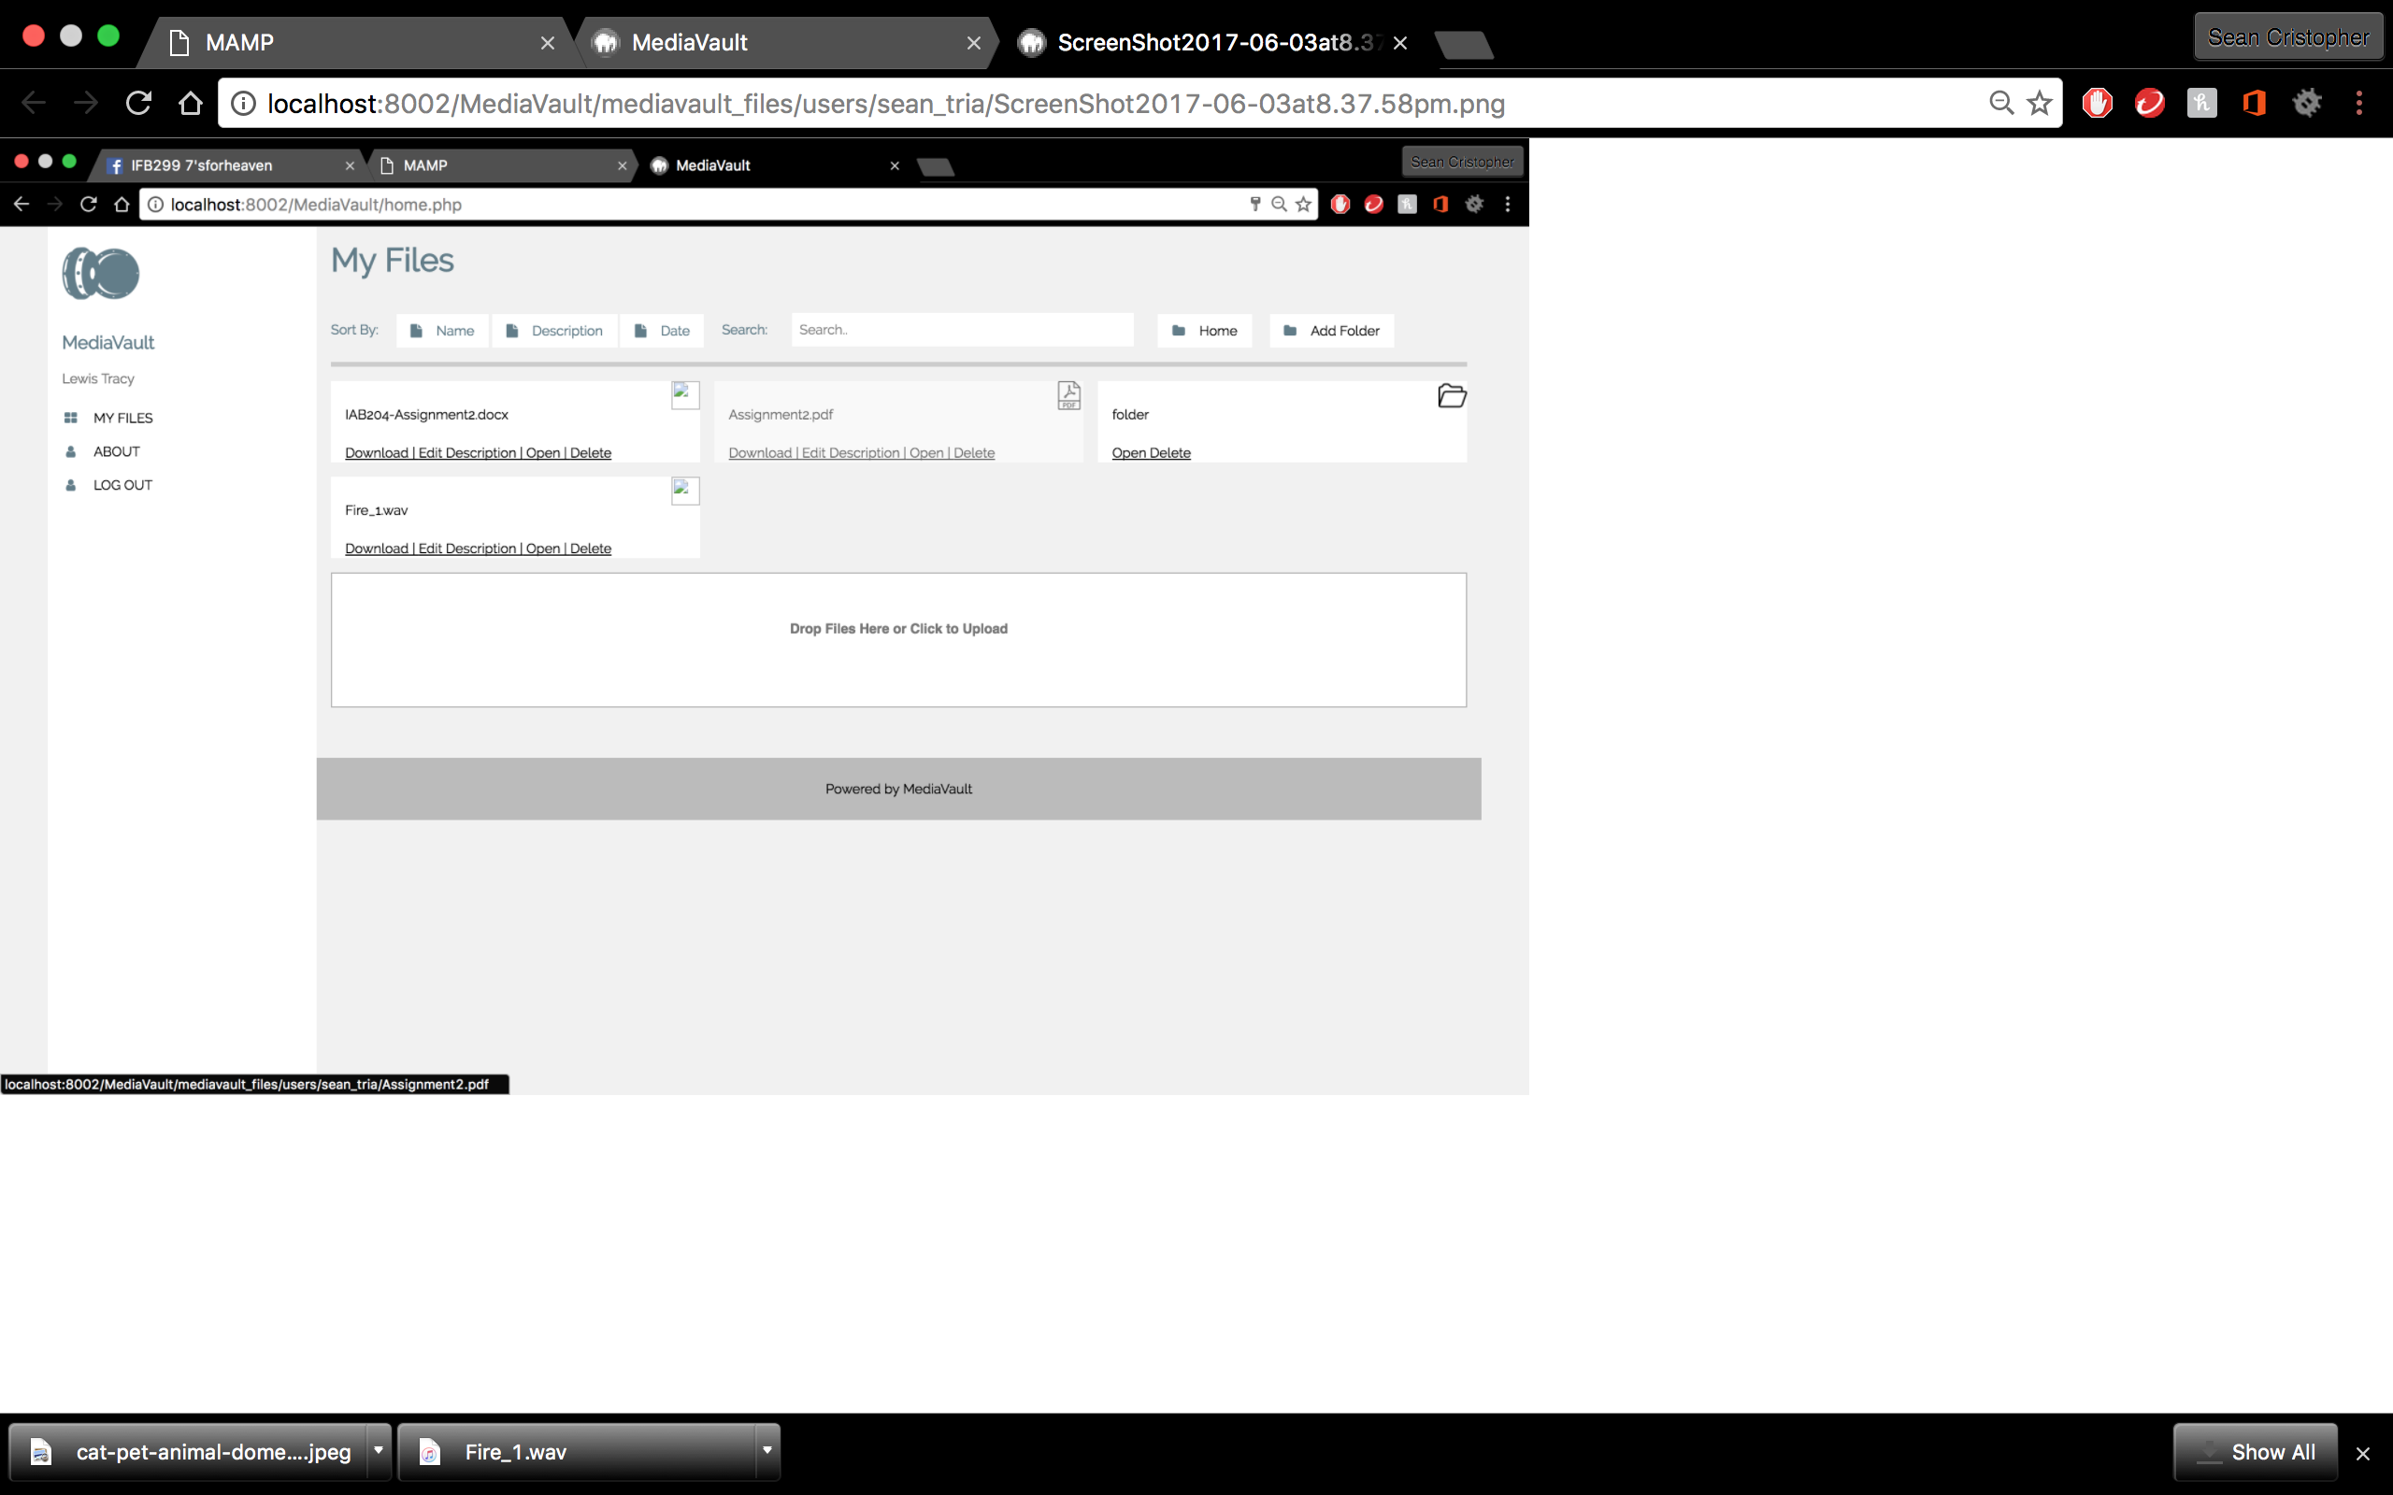

* “Open” button is independent for each file/folder
* PDF files successfully open on browser

Story 10B: Open my Folder

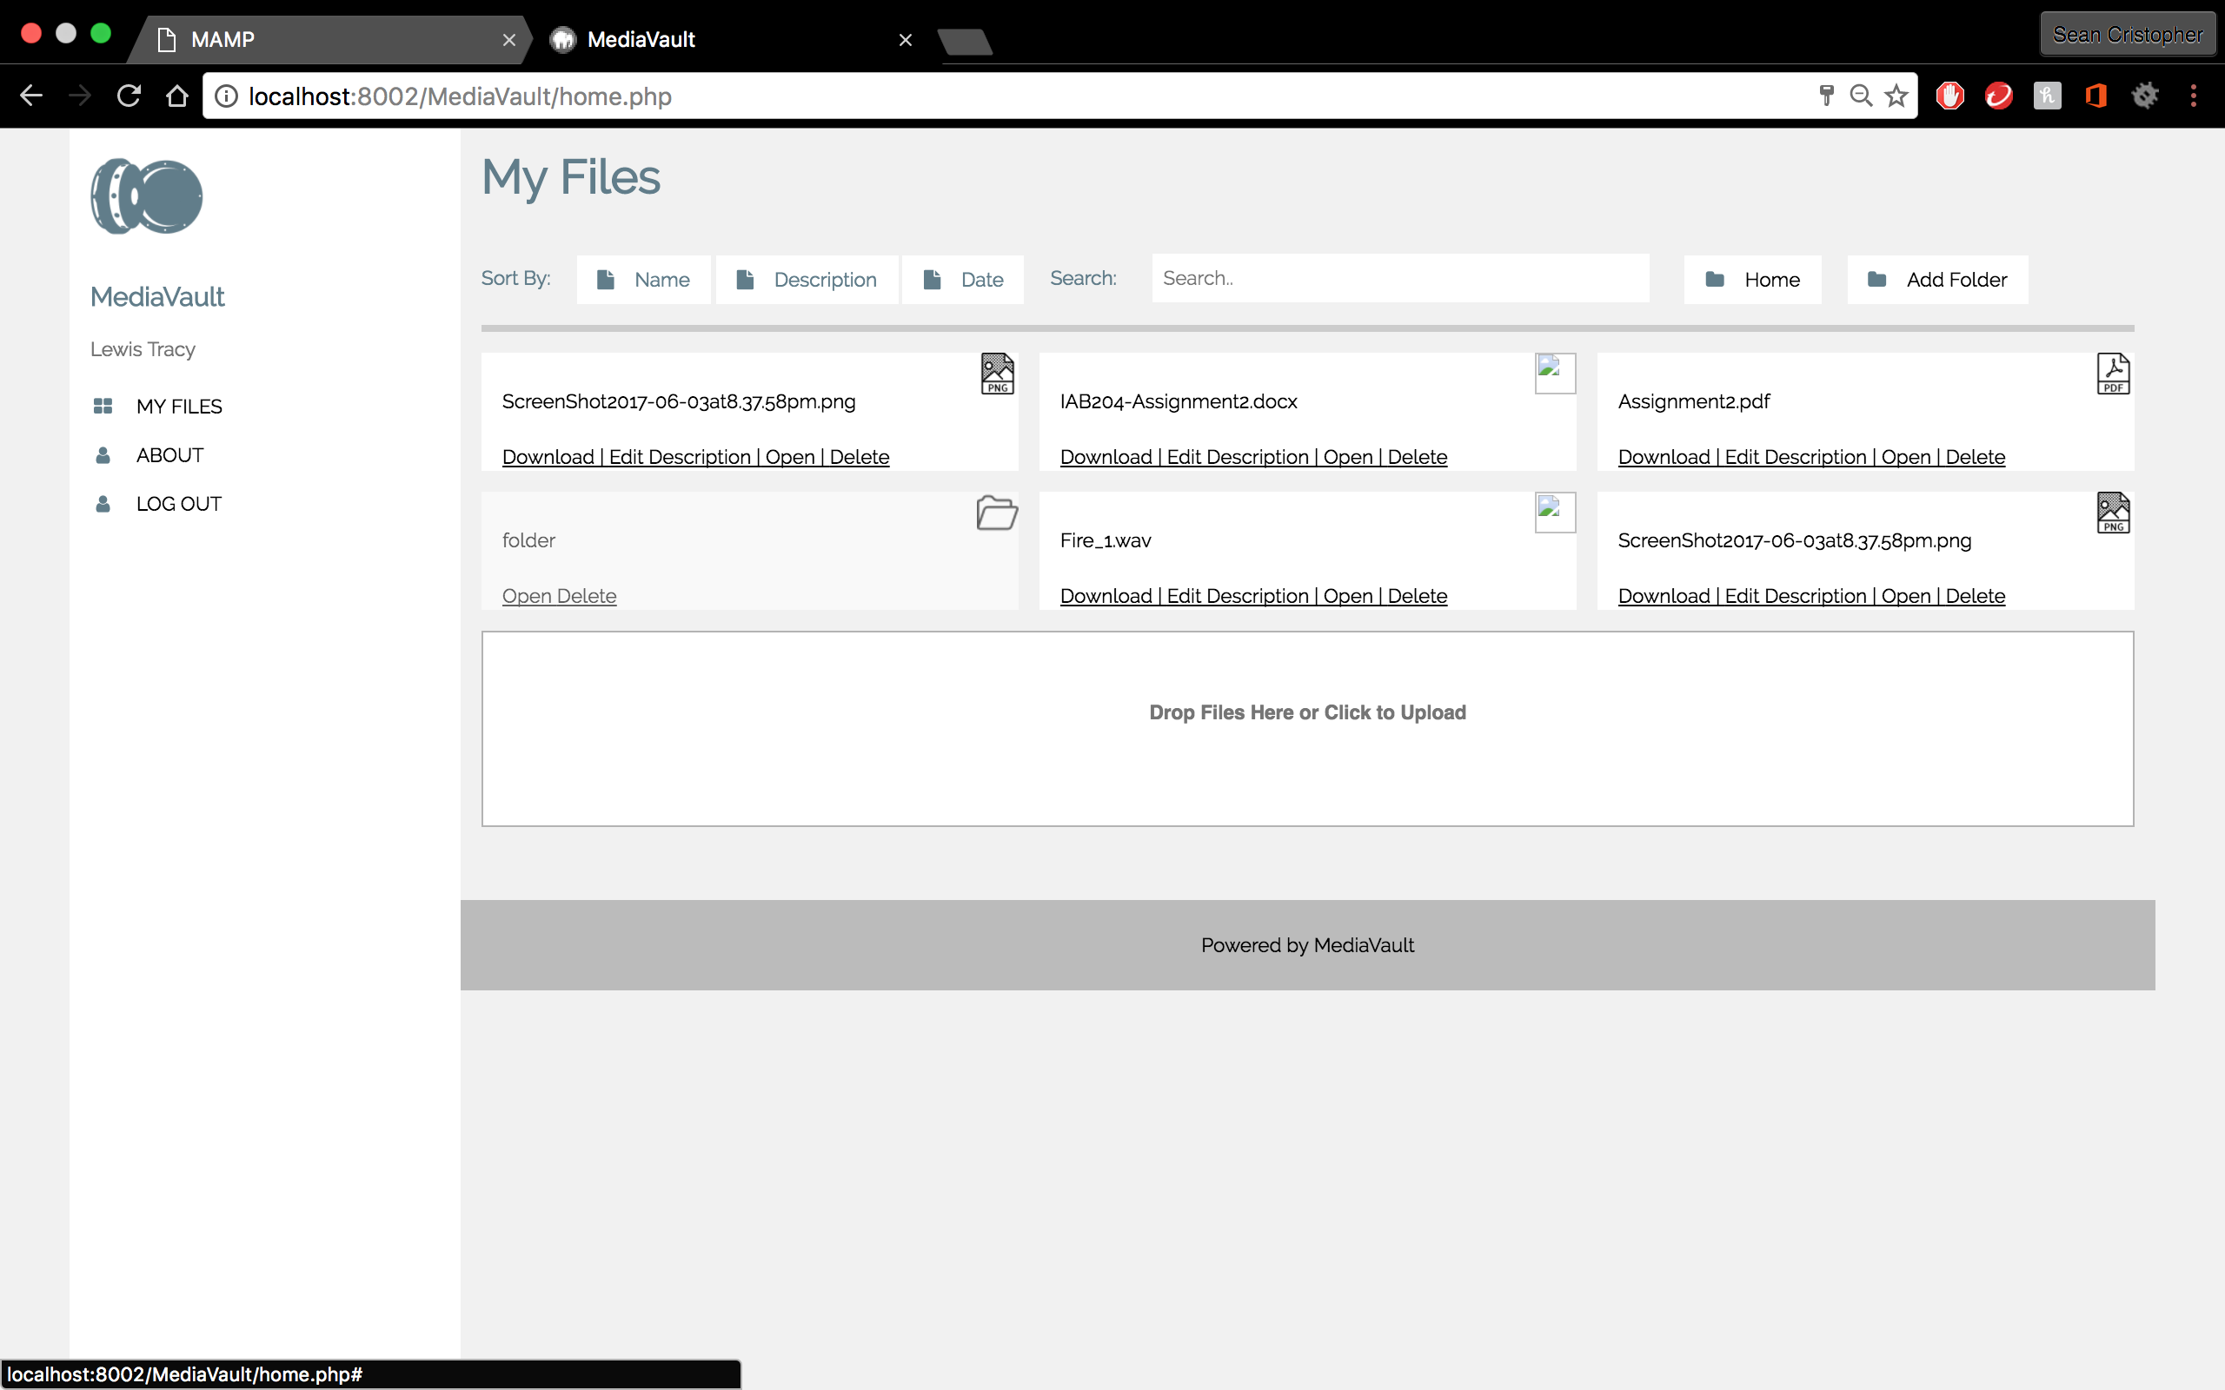

* “Open” button is independent for each file/folder
* Folder create successfully opens

Story 14: Add/Edit Meta Data to Uploaded File  
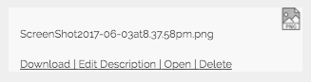

* Button “Edit Description” is added

Story 16: Manually Add Meta Data when Uploading files

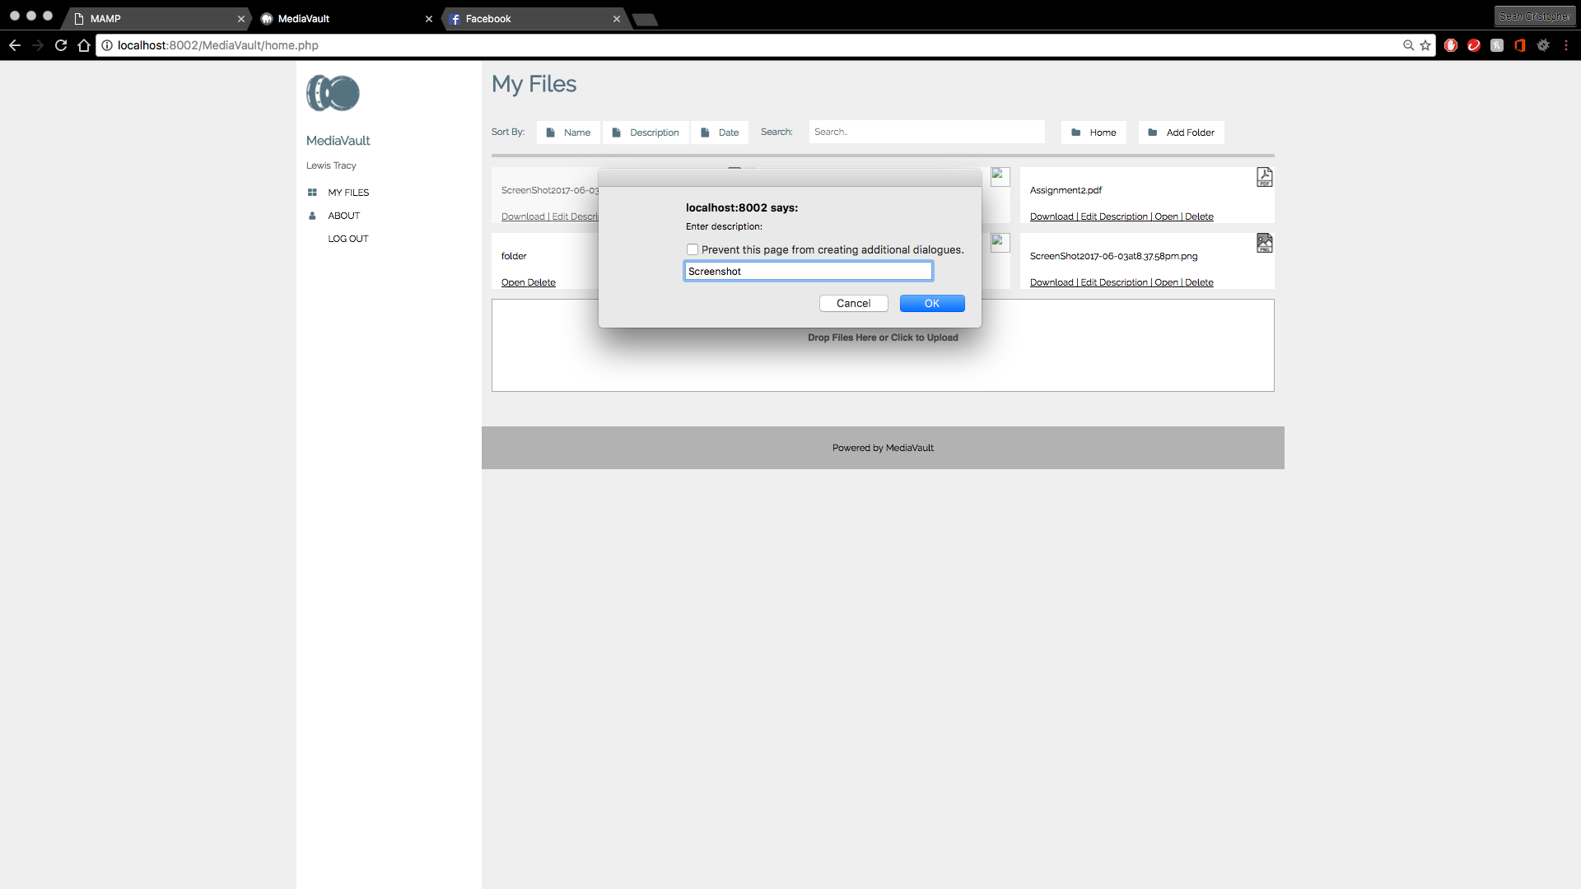

* Button “Edit Description” functions and adds a pop up message to edit file’s description

Story 13: Search a File

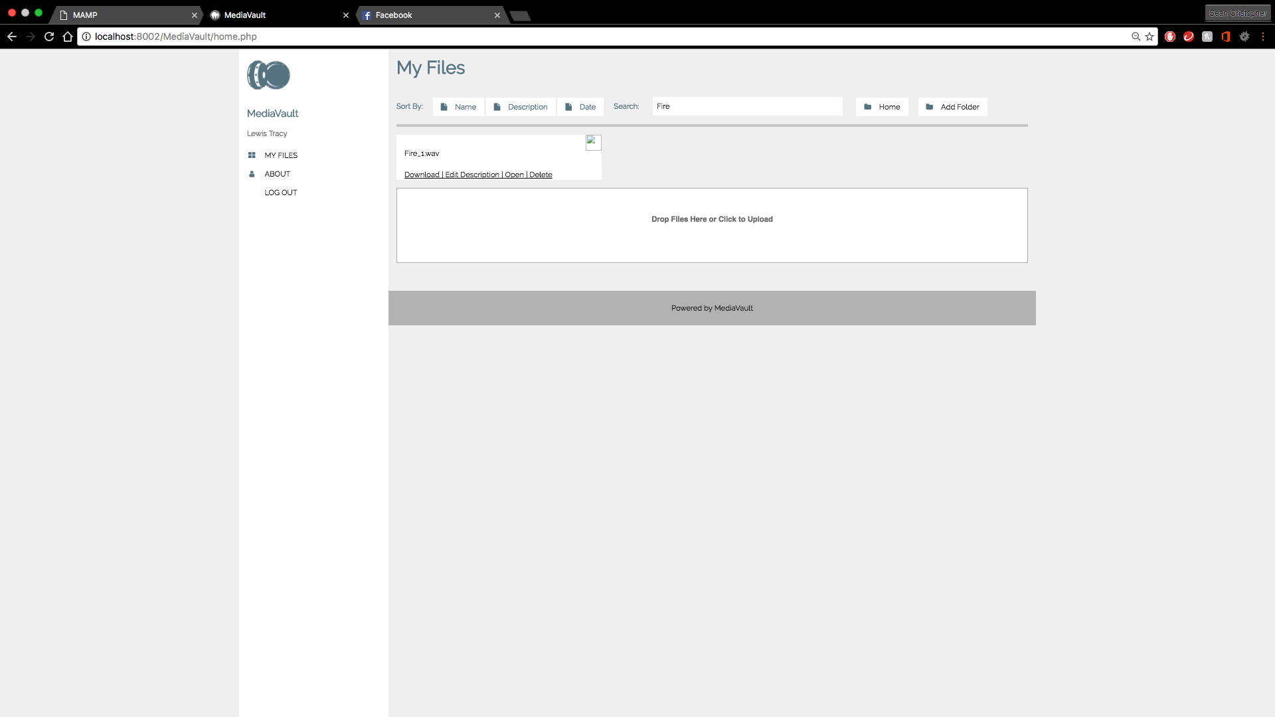

* Search box is added
* Test shows that search is functioning
* Retrieves the searched file from SQL search results

Story 16B: Automatically Add Meta Data when Uploading files



* Tests shows uploading a file/folder automatically adds meta data

Story 17: Sort Files – By Meta Data



* Tests shows that sort files by meta data doesn’t functions

Story 17B: Sort Files – By Name

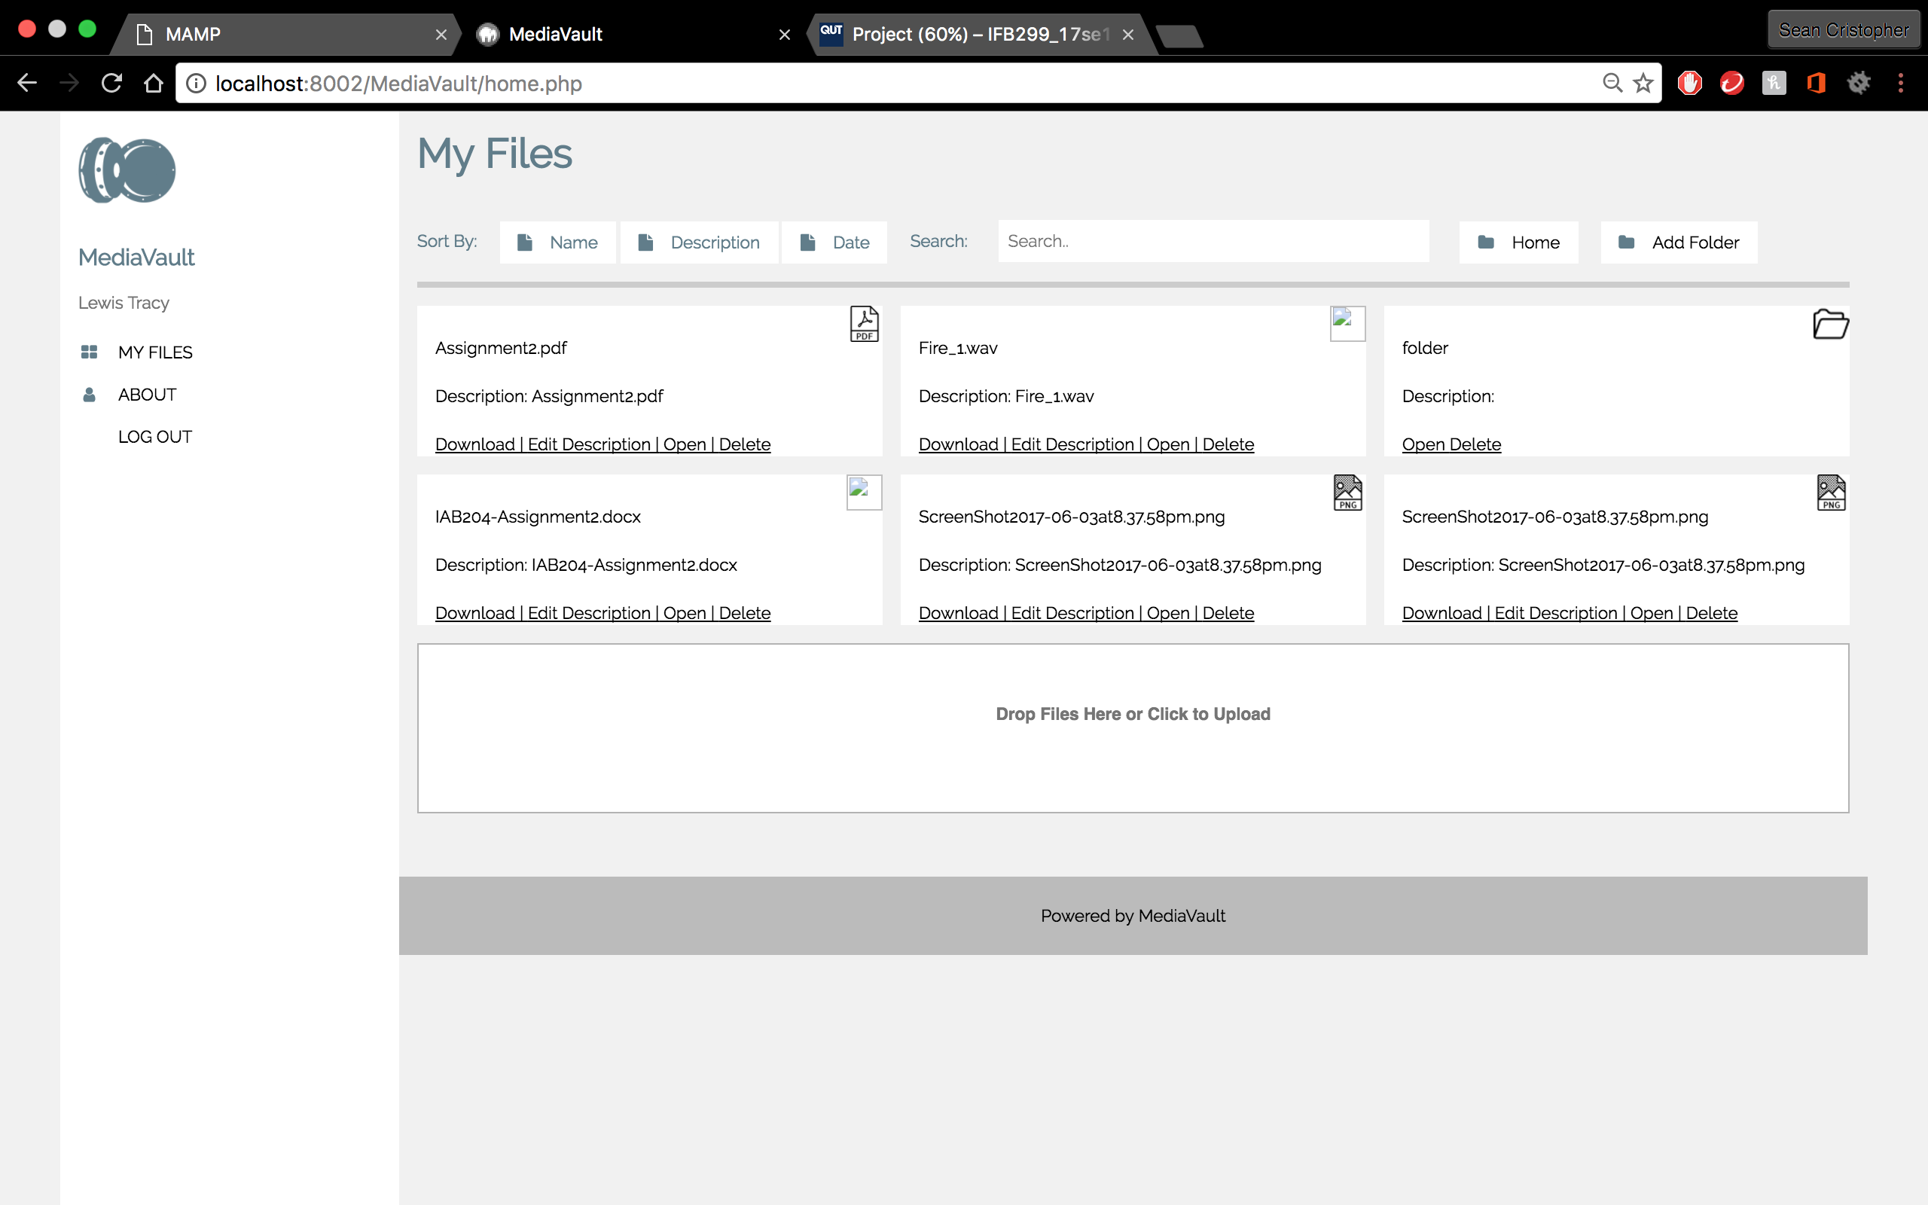

* Tests shows that sort files by name functions and sorts files/folders in alphabetical order of

Story 17C: Sort files – By Date



* Tests shows that sort by date doesn’t function

Summary: Testing shows incomplete user stories Story 17 and 17C are incomplete whereas other use stories are completed and functioning.